Ayodeji Williams
MIRACLE Research
Albany State University
Undergraduate Research
2025-2026 Cohort

Dataset: We downloaded mRNA datasets of osteosarcoma patients from the Target-OS database. We conducted an analysis using machine learning, here is what was found.
Data Visualization:
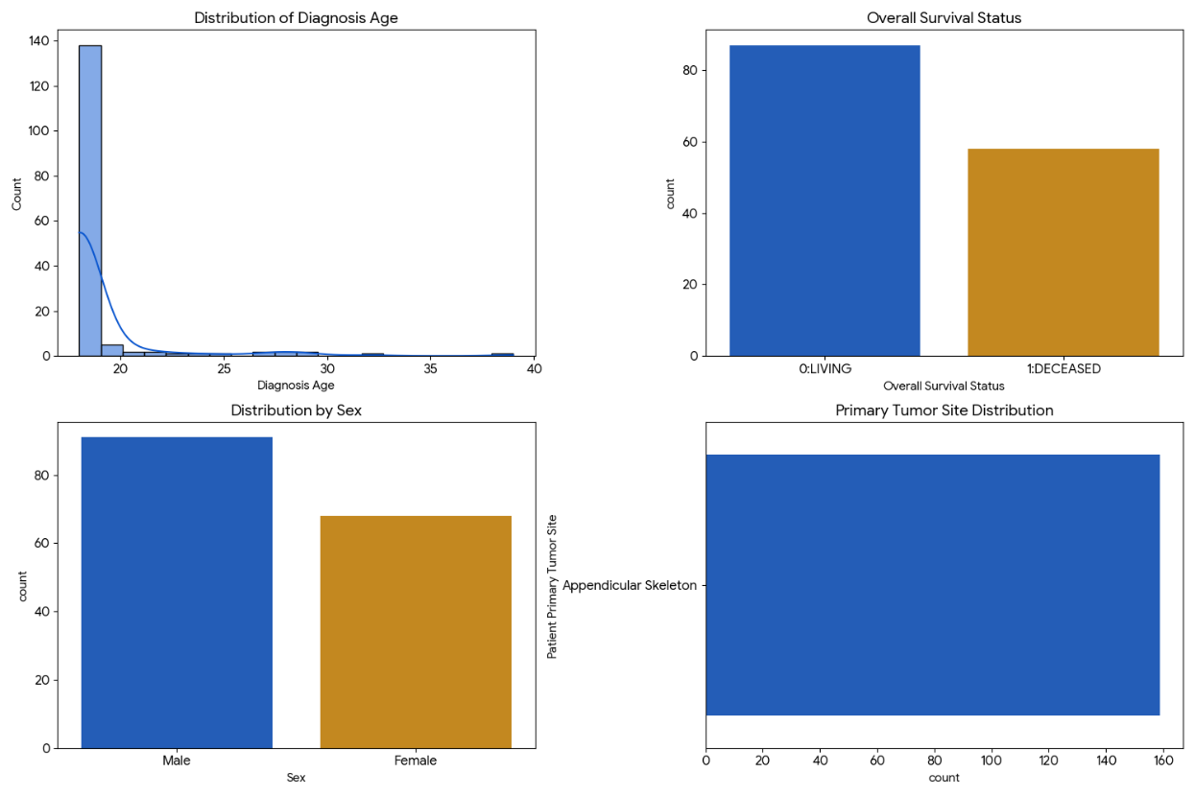
Findings
Based on the analysis of the 159 patient records:
- Target Label (Survival): You have a good distribution for a binary classification task. There are 87 "Living" and 58 "Deceased" patients. Your ML model can try to predict this status based on lncRNA expression.
- The Key Identifier: The Patient ID (e.g., TARGET-40-0A4HLD) is the most important column. This is exactly how you will "handshake" this clinical data with the gene expression files you download.
- Demographics: The cohort is predominantly young (as expected for Osteosarcoma) and all cases in this set are from the Appendicular Skeleton (limbs), which gives your study a specific focus.
- Missing Data: Note that 14 patients are missing survival status and 101 patients are missing the exact "Survival Months." For your first ML model, you should likely focus on the 145 patients where the status is known.

